# Executive Summary

## POC for registering Suppliers, Evaluators, and Presenters for the Innovation Drive & Technology Expo (IDTE)

## Project Name

## Project Number

## Program Name

## Program Number

## Project Manager

## Business Project Owner

## Executive Sponsor

## Program Manager

## Project Start Date

### December 17, 2018

## Project End Date

### June 2019

## Business Issue and or Opportunity

### The umbrella team needs a URL that all suppliers, around the globe, can access

### Suppliers will need an ID returned to them

#### Validating their email

#### Giving them access to an existing record that they can modify

### Suppliers should be able to see only their own records

## Strategic Initiative Supported

## Deliverables

### PowerPoint presentation showing proof of concept

### Deploy internal and external SharePoint sites

### Deploy set of Web Pages

### Deploy work flows

### Determine infrastructure needs to support solution

### Test

## Benefits

### Gather new ideas from Suppliers

## Approach to Measure Project Results (Key Performance Indicator)

### Supplier Hits

## Project Risks

### If some Suppliers cannot use, then IDTE will have to mitigate

### If resources are not available, then deadlines will slip

# Scope

## Goals

### Is to provide a system that offers adequate controls to protect against fraud and embezzlement and to guarantee the accuracy and security of data and information

## Objectives

## In-Scope

### Build Web Site

#### Registration Page

#### Evaluator Page

#### Modifications Page

#### Presenter Page

### All Ford Products

### Track hits

### Track email distribution that umbrella team sent this URL to

### Technology has to be Ford Approved

### Security Model

#### Suppliers cannot see other Supplier records

### Tell user that a title has already been used

### Must be available 24 x 7

### Must provide a help number in the event a supplier gets an error when they try to access

### Disclosure statement

### Must provide capabilities in all languages

## Out of Scope or Exclusions

### Do not need ip address of each user hitting site

### Products that Ford does not assemble or manufacturer

## Assumptions

### All Suppliers will have a CDSID with an Employee Type of S

#### This assumption implies that the user will not be a robot

### All email addresses provided will be valid

#### If email address provided returns an error, it is the supplier’s responsibility to fix

### Once the disclosure statement is accepted, the user will no longer be routed to that form

### Ford will rely on SharePoint Alerts to notify when a Suppler has registered

### SharePoint Alerts are smart enough to send notices of change to suppliers after Ford makes a change to one of their records.

### Part of the registration process will include automatically setting up alerts for Suppliers

### A link to contact us via email will be provided in the event of a Supplier having an issue with a web page

### The Suppliers will find it easier to perform their role and trust that their information is secure.

### The Suppliers have accepted that acceptance notices will take a minimum of 1 day. This is currently a constraint from the SharePoint Workflow.

### Technology used has a maximum life cycle of 7 months

### Ford will be able to configure the internal SharePoint site to improve response time in the event more than 5 users cause poor performance.

### IDTE will

#### Train the Suppliers

#### Ensure the Suppliers understand this is just for registration

#### Help test this web page and data model

#### Create the disclosure statement

#### Propose a list of Ford users around the globe for testing

#### Send email out to all eligible suppliers

#### Watch for SharePoint email stating a Supplier has registered

#### Work with the task list to generate the code and send the email accepting or rejecting the Supplier

#### Offer adequate service level and capacity

## Deliverable Scope

### Proof of Concept to consist of a deck

## Project Control Milestones

### POC delivery January 3, 2019

## MS Project Plan

### Will be used for forecasting and tracking actual work

## Financial Scope

### Spending

### Operating Expenses

### Financial Benefits

## Risk Analysis

### Critical Risk Factors

#### Ford get notified when a Supplier completes the registration form. This notification must take place in a timely manner.

#### Suppliers get notified when Ford accepts or rejects the idea or the dates chosen. This notification must take place in a timely manner.

## Scope Management Approach

### This document will be used until an enterprise system becomes available

## Issues Management Approach

### This document will be used to track and close issues

### If a supplier experiences issues with any web page, how will they communicate that issue

## Risk Management Approach

### Risks will be tracked and mitigated in this document until an enterprise system becomes available

### Risk

#### If the response time the Supplier experiences from the set of HTML pages as they load via navigation is poor, then the approach will be changed to one page and making objects visible as the role demands. Some of this work has to wait for SharePoint Designer application approval

## Quality Management Approach

## Implementation and Transition Management Approach

## Communications Management Approach

## Project Organization

|  |  |  |
| --- | --- | --- |
| Role | Description | Responsibility |
| Sponsor |  |  |
| Project Customer |  |  |
| IT Project Owner |  |  |
| Program Manager |  |  |
| Project Manager |  |  |
| Project Team |  |  |
| Stakeholders |  |  |

# Features / Stories / Test Cases

## Feature

### When the Suppliers receive an email from the IDTE team announcing this Innovation Drive, each Supplier will be able to register for this event by utilizing the URL in the email, the code returned by this system and a code the supplier provided during registration.

#### Story

##### As a Supplier preparing to register for the IDTE I want to ensure the computer I plan to use will allow all the functionality of the web site to work properly so that I can ensure the Supplier I represent is registered properly.

#### Story

##### As a Supplier preparing to register for the IDTE I want to ensure the email I provide works so that I can ensure the Supplier I represent is registered properly.

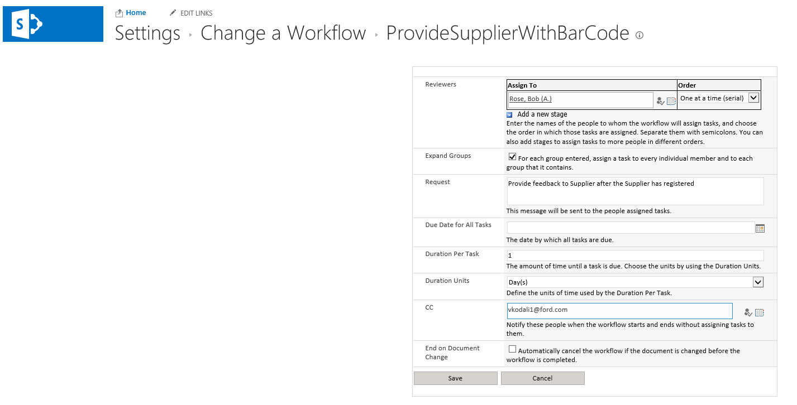

#### Story

##### As a Supplier preparing to register for the IDTE I want to ensure no other Suppliers can see my innovation so that I have time to finish my patent process.

###### Task – A security model will be put in place to allow only the registration web page to be seen by Suppliers.

###### Test – Can supplier see the evaluator page when given the url?

###### Task - A security model will be put in place to allow only the data pertaining to the select supplier CDSID will be visible.

Test – Can supplier see any other CDSID even after connecting with Excel?

#### Story

##### As the Create New Item SharePoint Workflow on the Supplier list, I need to generate the bar code and send it to the Supplier so that the Supplier can update the registration form as needed.

#### Story

##### As the Create New Item SharePoint Workflow on the Supplier list, I need to replicate the calendar selections to the Presenter and Evaluator lists.

#### Story

##### As the Create New Item SharePoint Workflow on the Supplier List, I need to change the image on each day on the Calendar to show graphically how much space is left on each day.

#### Story

##### As a Ford Representative, I need to notify the Supplier that there is no room on the selected dates so that the Supplier has the opportunity to change their selection but I want to reduce my efforts exchanging emails so I need to rely on each Supplier alerts being activated automatically.

With the Designer permission level, work flows can be created

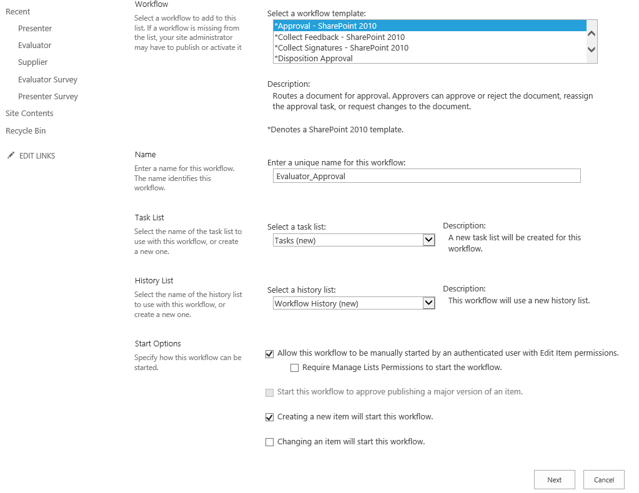

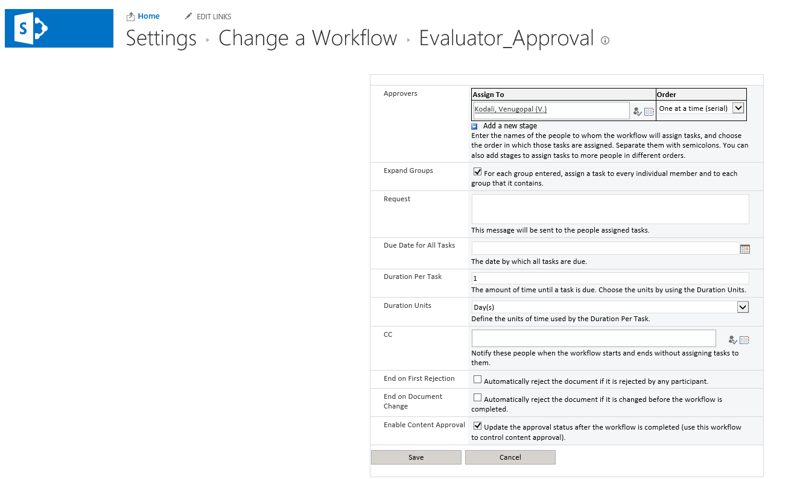

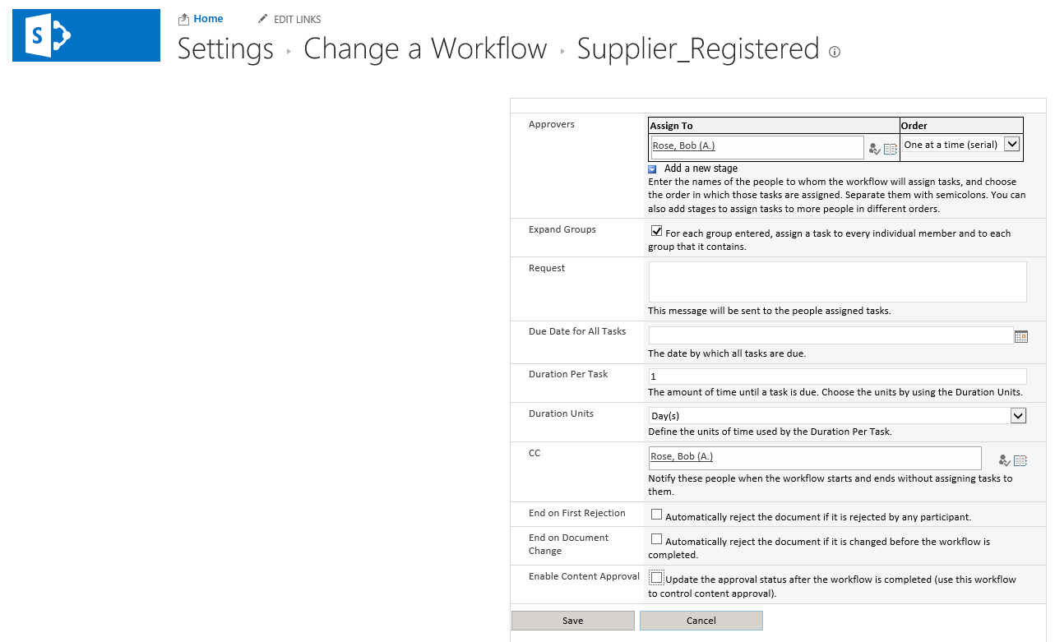

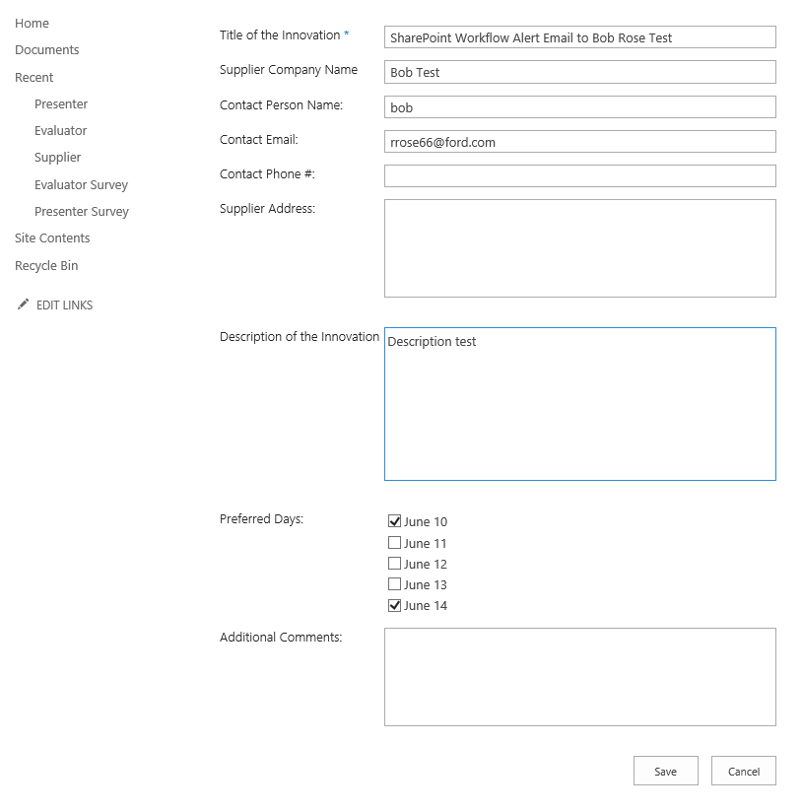

#### Story

As a Supplier who has already registered, I want to ensure that I do not have to complete the disclosure form again so that I can reduce my efforts while scanning to see if my dates have been accepted.

#### Story

As a Supplier who has already registered I want to ensure that I can update the details so that the Supplier I have has the best chance of getting selected to attend this event.

#### Story

As a Supplier in Germany I want to ensure that if I register for this event utilizing the German language and the German keyboard that the web site will do the proper conversions so that the Ford team will understand what I am communicating.

#### Story

##### As an Evaluator, I want to

#### Story

As a business representative of Ford I want to measure the effectiveness of the original email to Suppliers by counting the hits on the main web page so that the system can be justified.

#### Story

As a business representative of Ford I want to ensure each that Supplier understand and signs a disclosure releasing Ford from all liabilities.

#### Story

As an IT project manager I want to ensure the technology selected for this system will be still exist for the event next year so that cost benefits can be realized.

#### Story

As a business representative of Ford I want to ensure this system is available 24 x 5 so that Suppliers in all regions of the globe can register during normal working hours.

#### Store

As the IT support representative of this system I want to ensure a team of testers exists in all regions of the globe so that the system performance and response time can be measured.

#### Story

##### Each supplier will have one GSDB code

##### All users from same supplier can use the same code

##### System had a number of tabs

##### Suppliers make printout of layout of event

##### May want a customized ribbon

##### How big is each team

###### The supplier

###### the evaluator team 120

evaluator work is out of scope

##### might need to be compatible with iphone and or tablet

# Design

## Study the feasibility on the following Ford Supported Technologies

### C#

### Java

### SharePoint Designer

### InfoPath

### Any Microsoft Office application linked to SharePoint lists

### Ford Hosted Web Site with Java Applets and text files

#### Assuming a limited budget

#### Web site to hold a few

##### html web pages

##### text files

##### Java Applets

#### When user goes to the URL first time

##### Hosted Ford html page records the visit

##### The hosted Java Applets copies

###### Supplier html page

###### Supplier java applet

##### Once the java applet reaches the supplier

###### Discovers computer hardware and software

###### Alters user if computer is not at standard level

#### When user submits registration

##### Local applet

###### gathers entries into XML file

###### sends XML file to host server

##### Host applet

###### Generates a new ID with CDSID for the record

###### Sends new XML file with ID back to supplier

##### Local applet

###### Refreshes ID object reading the new XML file

## Solution Alternatives

### All Alternatives will take the approach of manually building HTML page(s) and rely on SharePoint Alerts until SharePoint Designer is available and increase security as time allows utilizing REST to update the SharePoint lists

### Provide a set of pages using JavaScript to allow the Suppliers to navigate

### Provide one page that makes objects visible utilizing JavaScript per role per requirement

## Leverage Ford source

## Follow applicable Standards

## Feature, Stories, Tasks, Test Cases, Defects (see Rally)

## Field Name, Definition, Constraints, Test

### Registration Page

#### Supplier

#### Supplier Name [text]

#### Supplier ID [unique ID]

#### Presentation Title [text]

#### Presentation ID [unique ID]

#### Submitter Email [text]

##### If not valid, supplier is responsible for fixing

##### They will know if they do not get an email with an ID in the next 10 minutes

#### Submitter Phone [number]

#### Address1  [text]

#### Address2 [text]

#### City/Province [text]

#### State [text]

#### Country [text]

#### Contact Name [text]

#### Contact Email  [text]

#### Contact Phone [number]

#### Presentation Details [extended text]

#### Attachments [attachment]

#### Dates [dates for selection]

### Evaluator Page

#### CDSID

#### Presentation ID (from list above)

#### Dates attending/reviewing

### Presenter Page

#### CDSID

#### Presentation ID (from list above)

#### Dates presenting (per each presentation)

## Smoke test

# Develop

## Source

## Communication Plan

### All Communications will be tracked here

### Meeting Minutes from 20190131

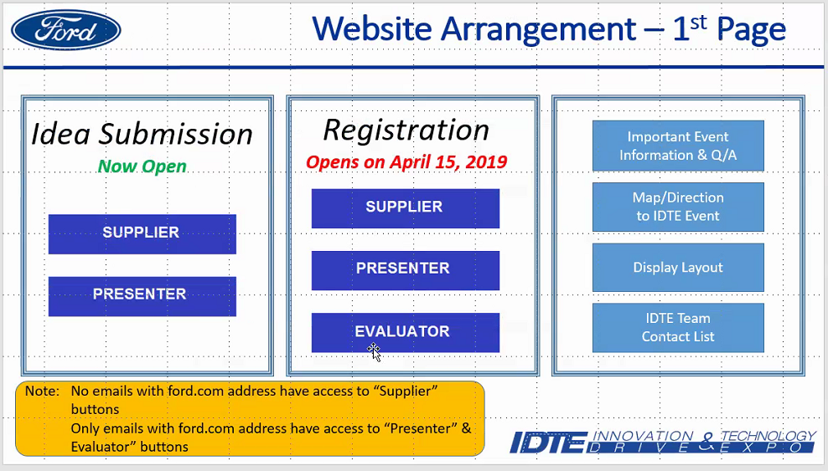

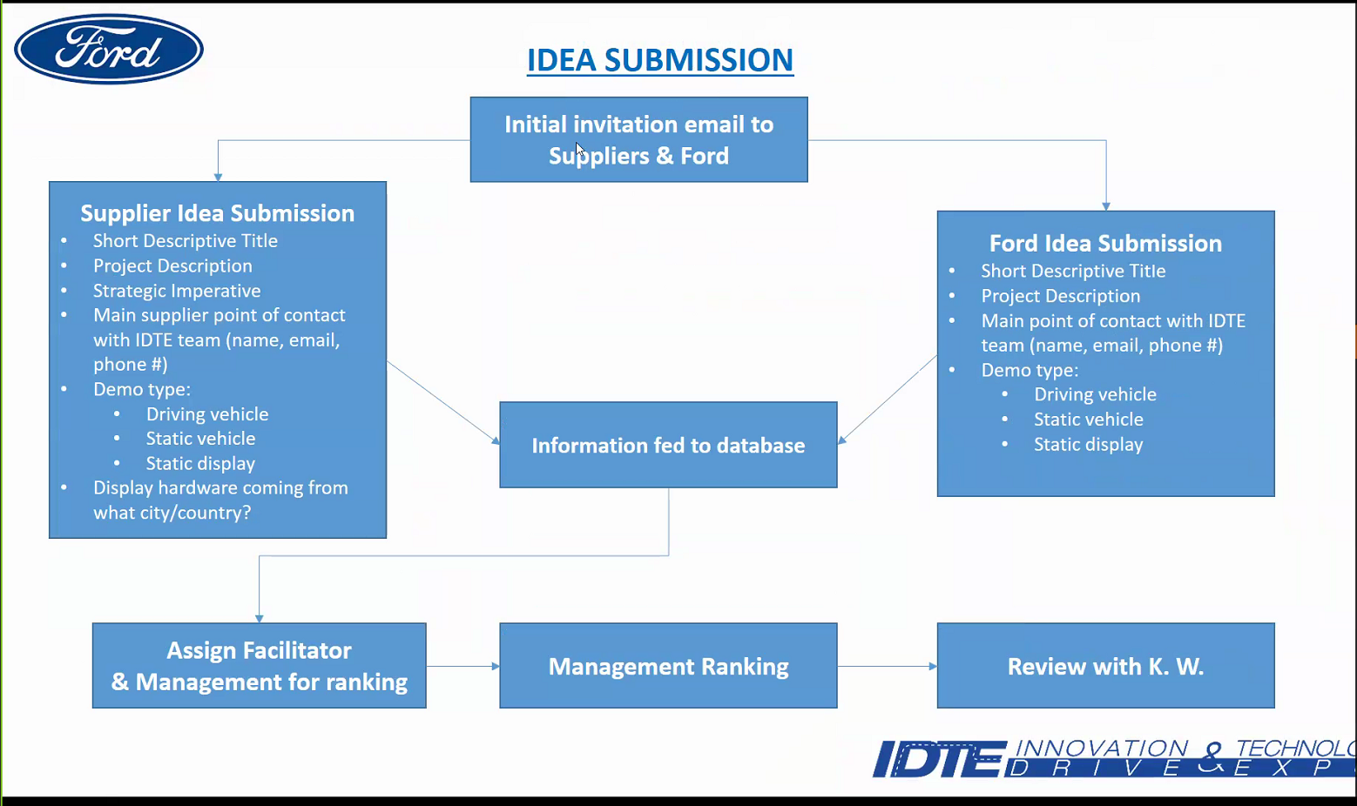

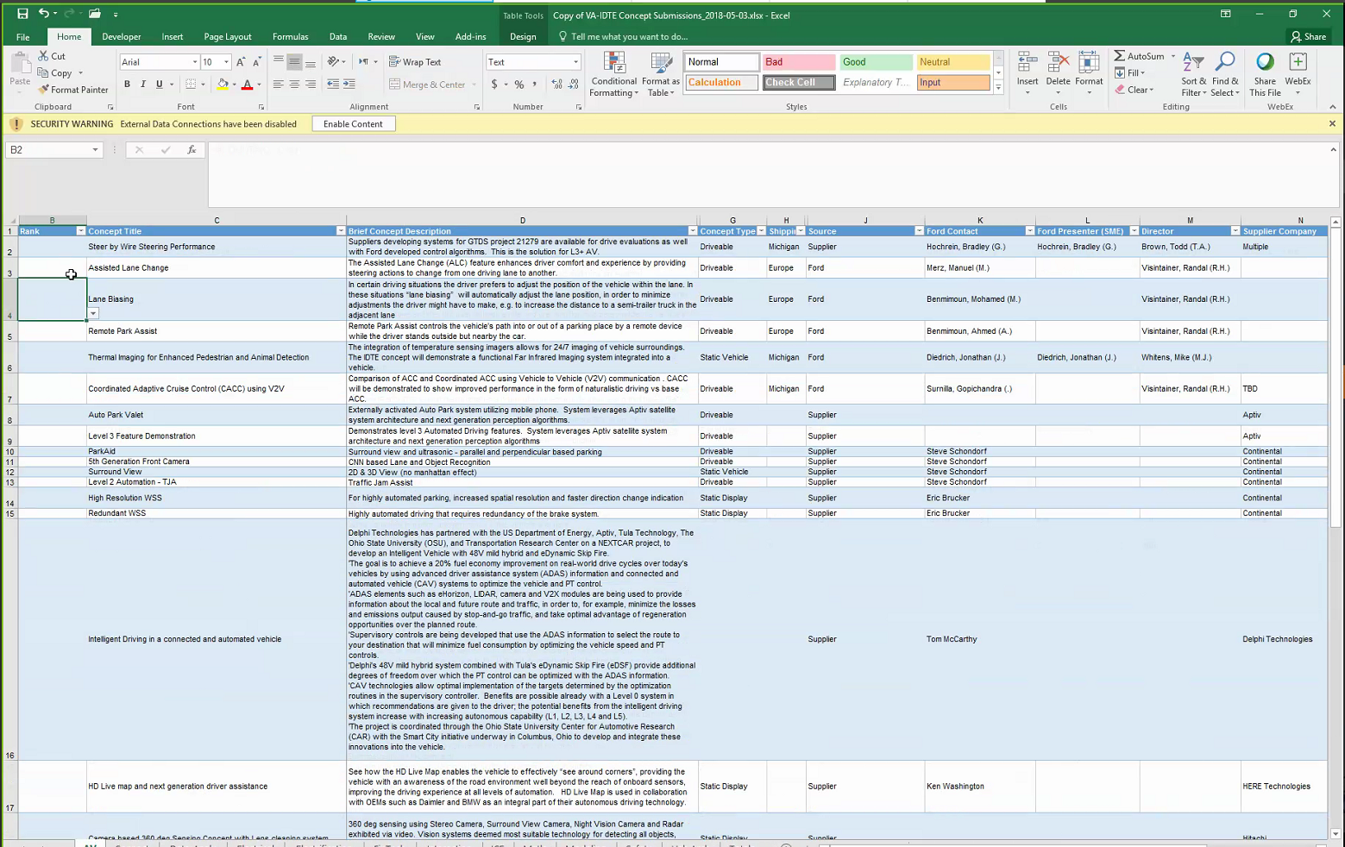

Only a limited amount of presenters can be accepted

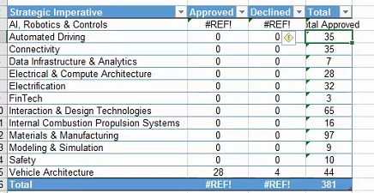

Europe also evaluates

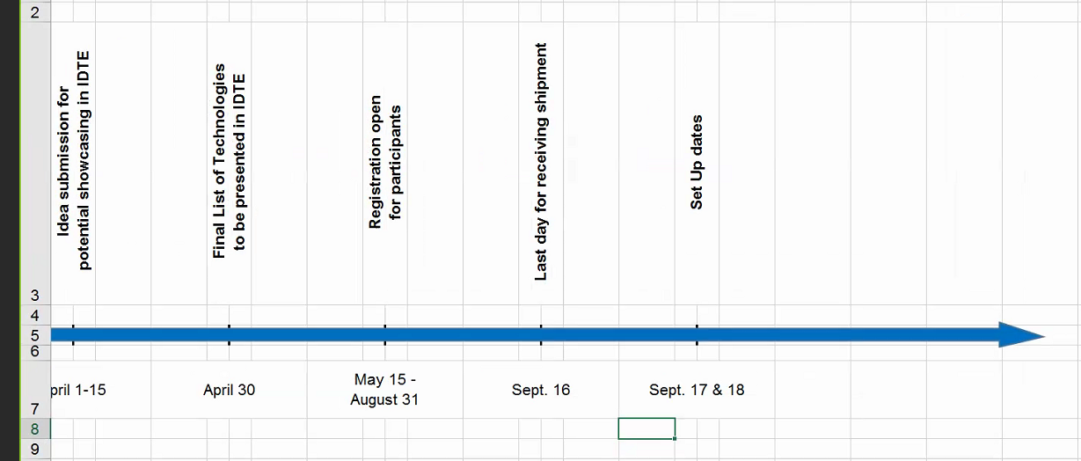

Might be changed to March

Probably want to test the excel macro that updates sharepoint list

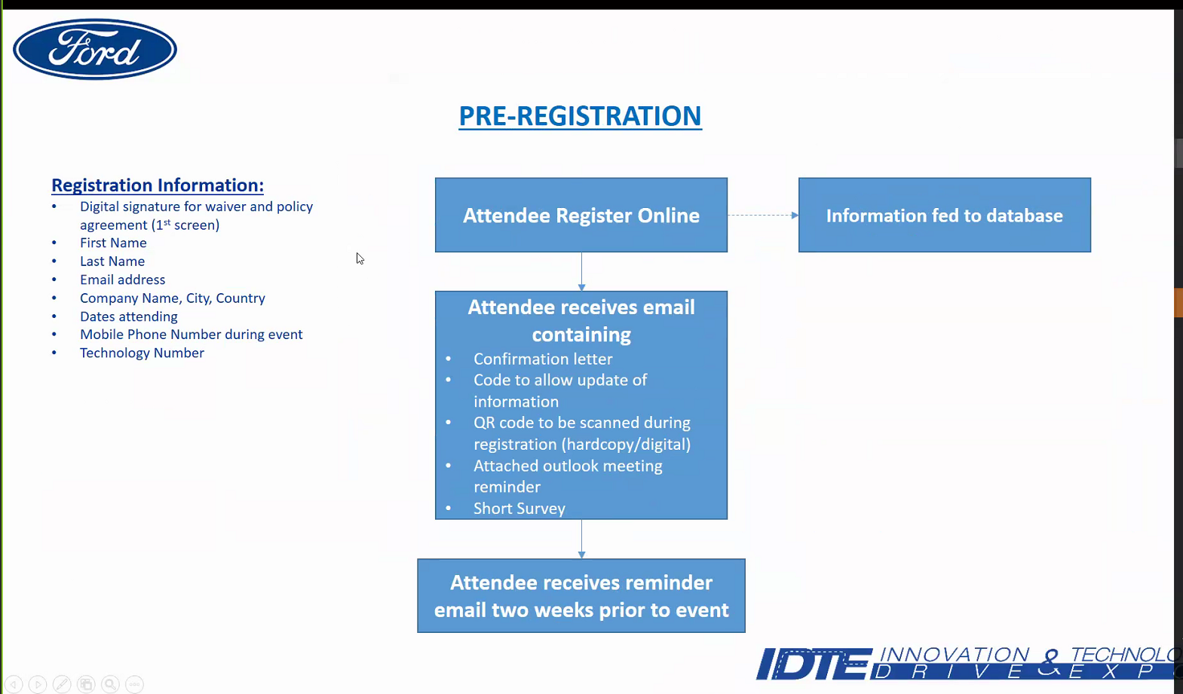

Updates take place as dates need to be changed

People come for the full day

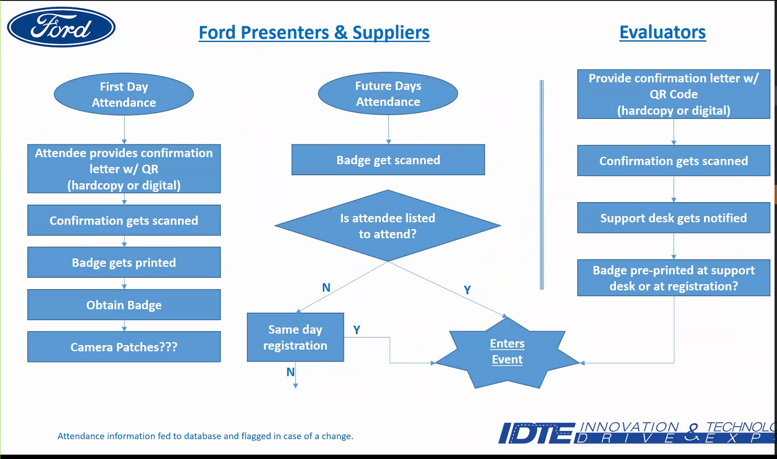

Evaluator will be there for only one day

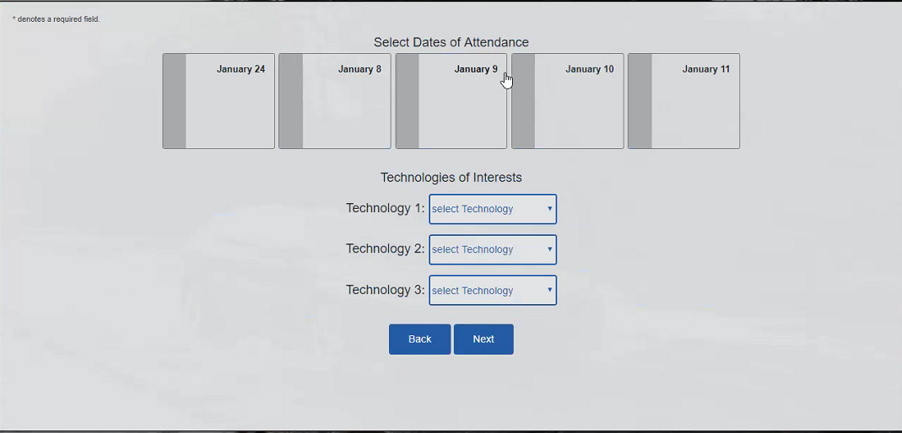

They should be given preference days

They have a generic email

50 percent need the external site and each supplier needs a few people with access

Individual email addresses are needed

Excel user

### Meeting Minutes from 20190124

#### First Page

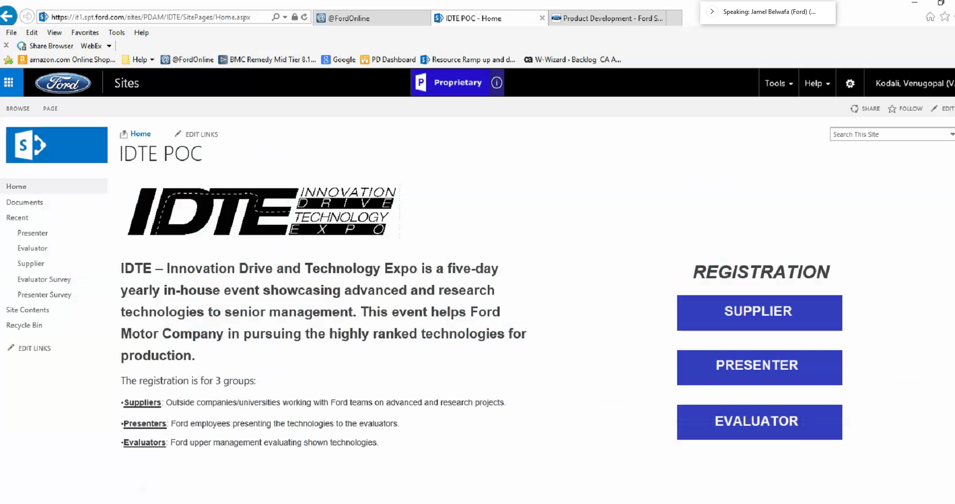

Jamel is putting together a flow chart

They have a site but they would rather have a new one

Not sure about the external user

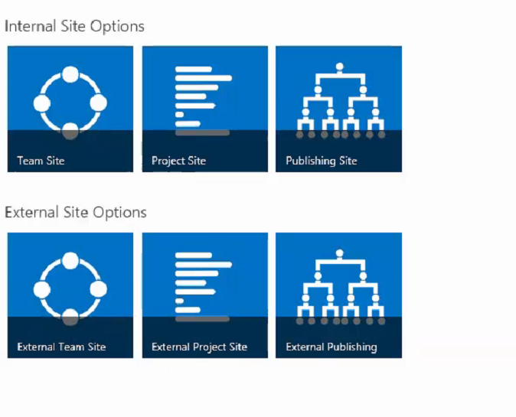

Which site is most appropriate

External Team Site is target

External Project Site is better

Migrate

Code needs to be generated from SharePoint

#### Jamel slide 1

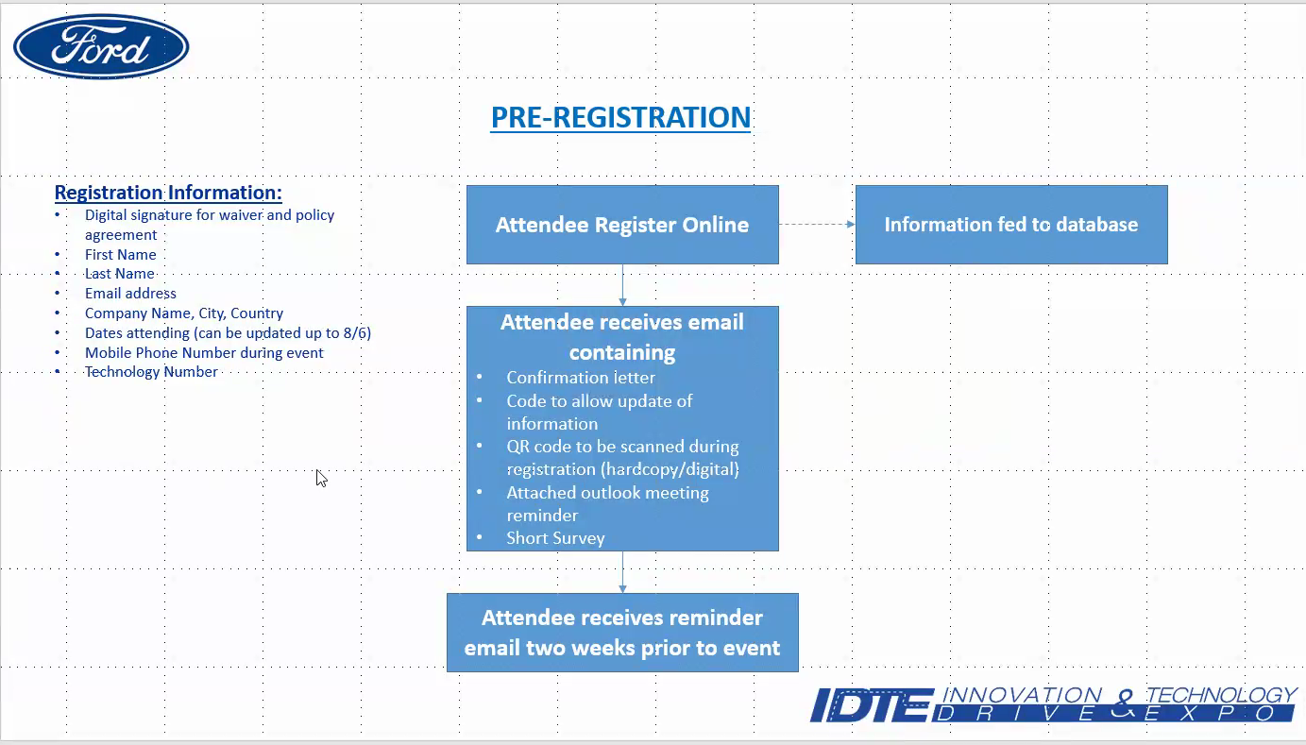

Need a code for updates

Outlook meeting reminder

#### Jamel slide 2 showing flow between roles

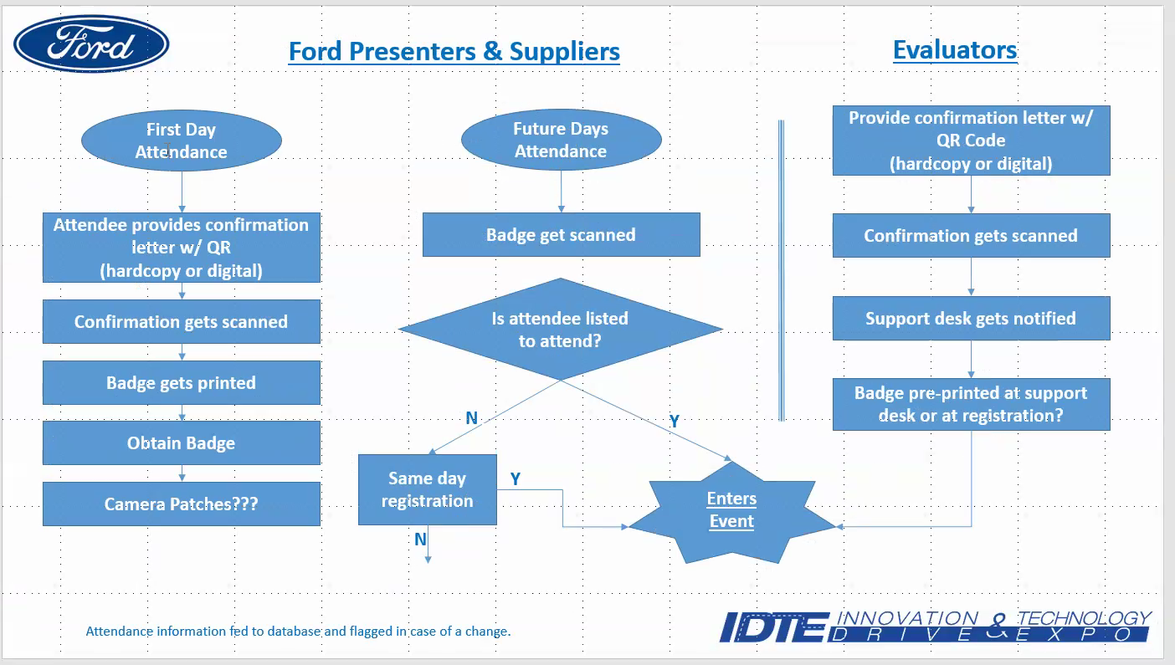

They provide confirmation letter to enter building

Evaluators go to a special desk to check in

Also Send an email to all Ford employees

Accept about 150 ideas

This is a page developed by the college students

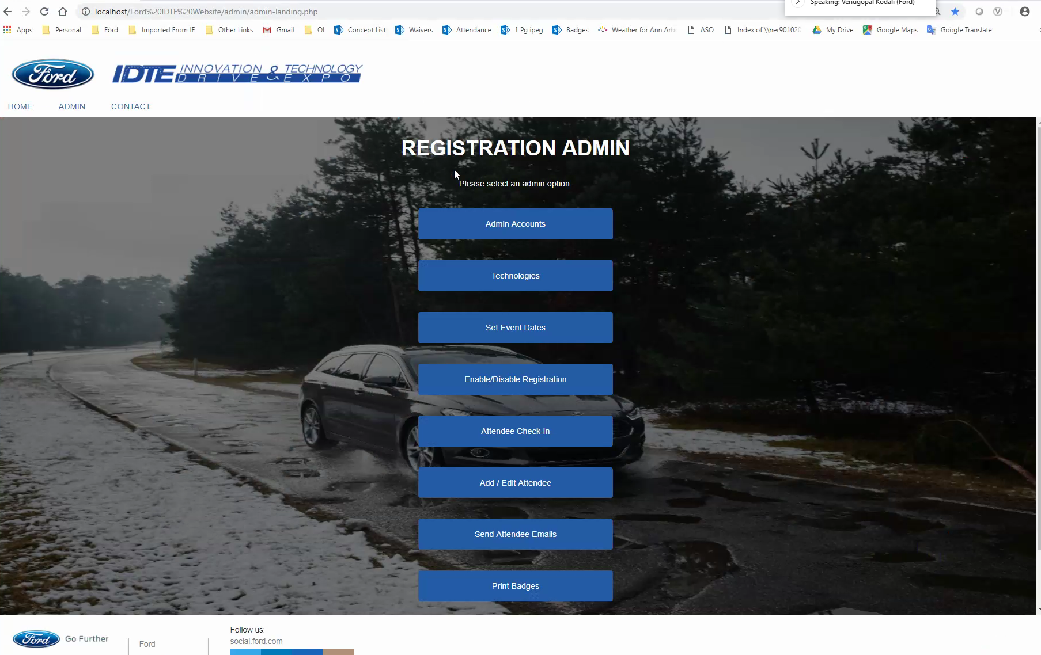

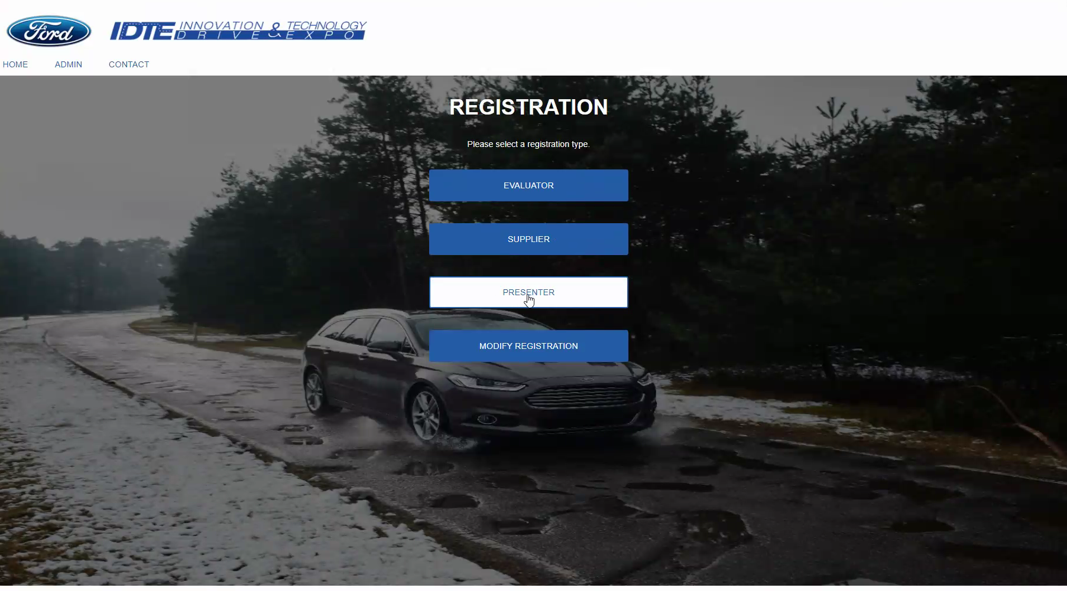

Disclosure signed

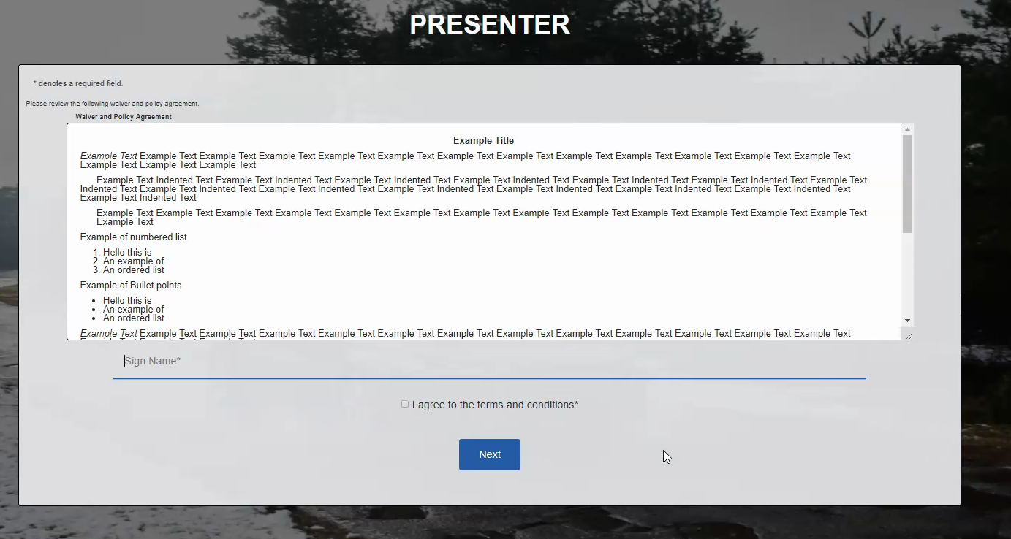

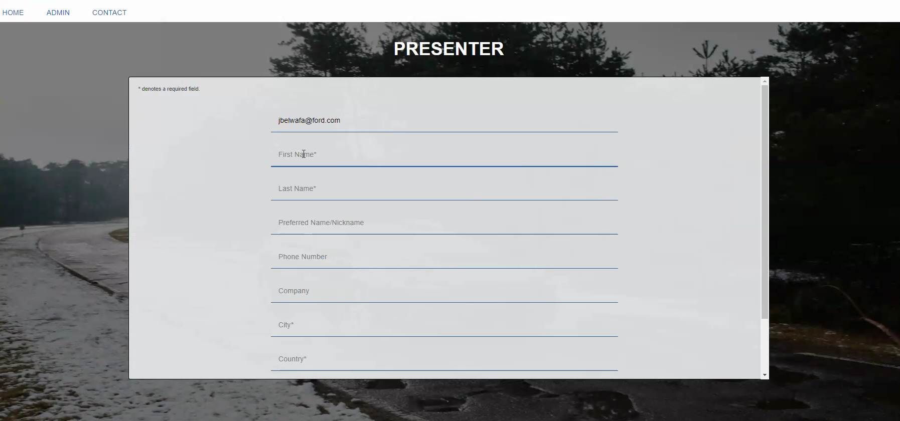

Probably don’t have to match names due to variances

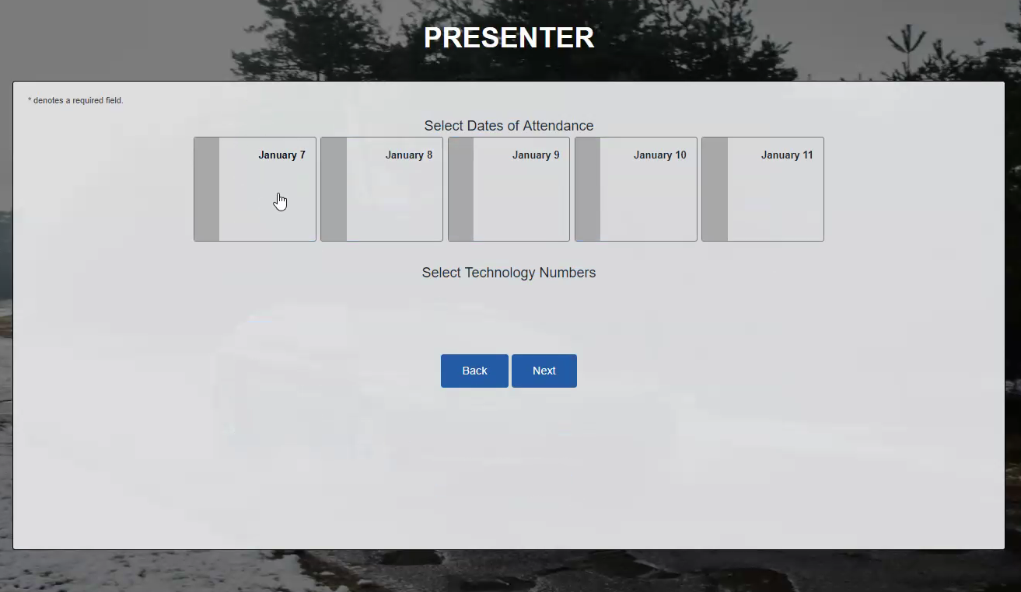

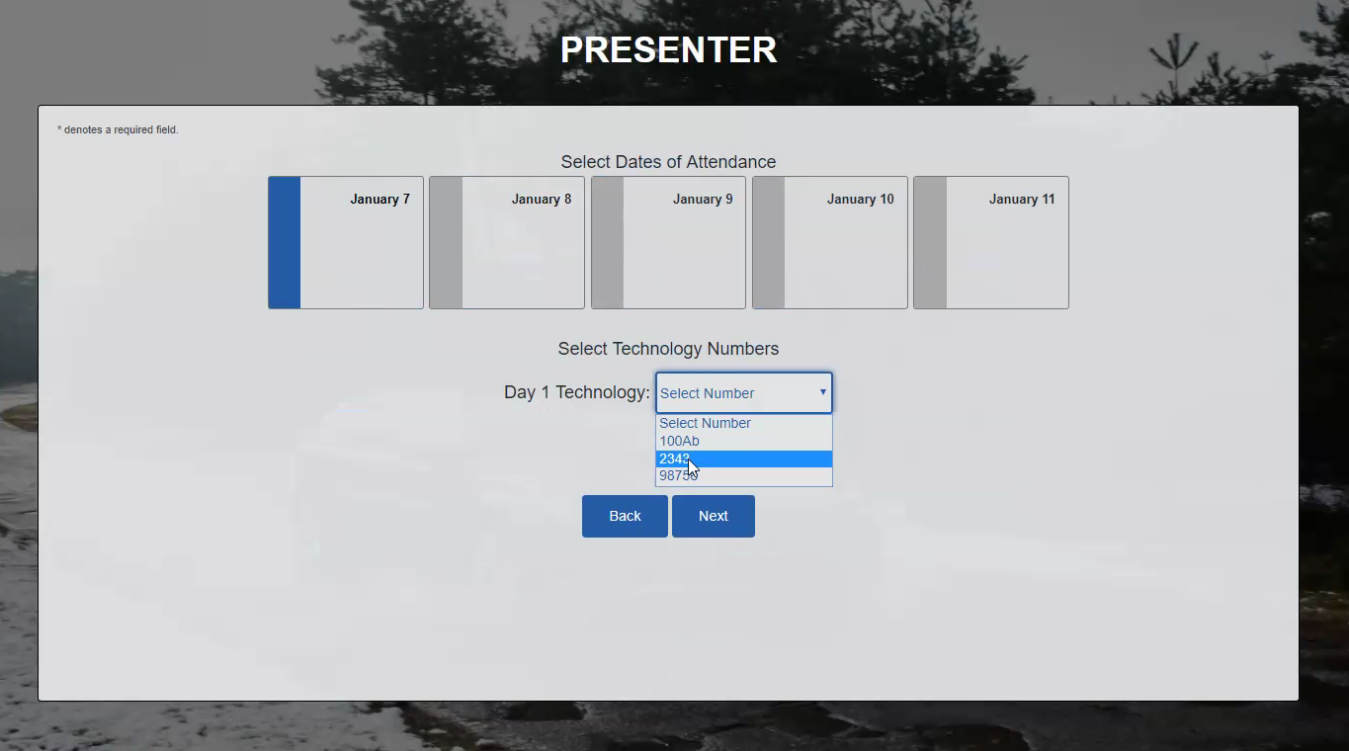

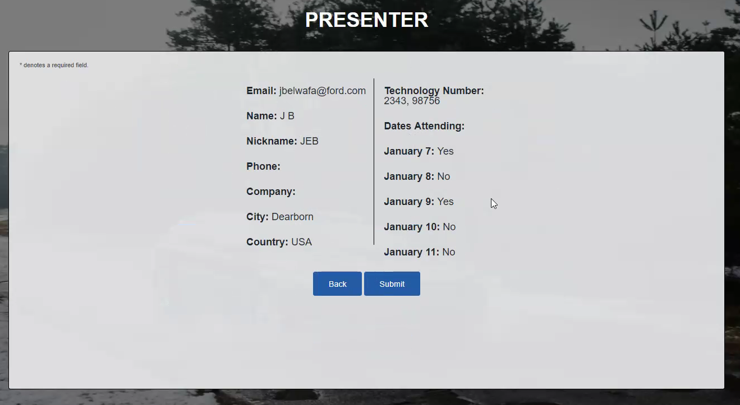

Technology number needs to be in front of each date

Confirmation email

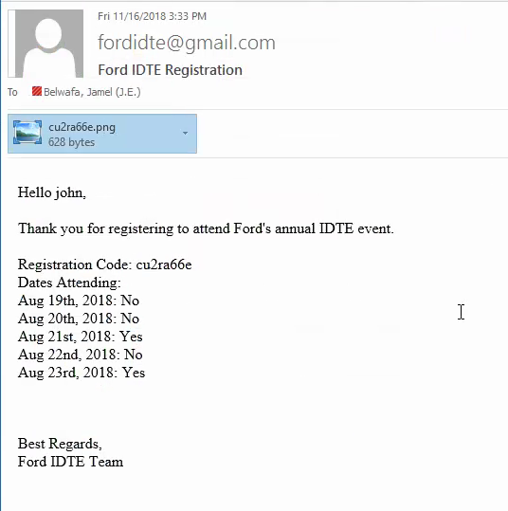

Attachment

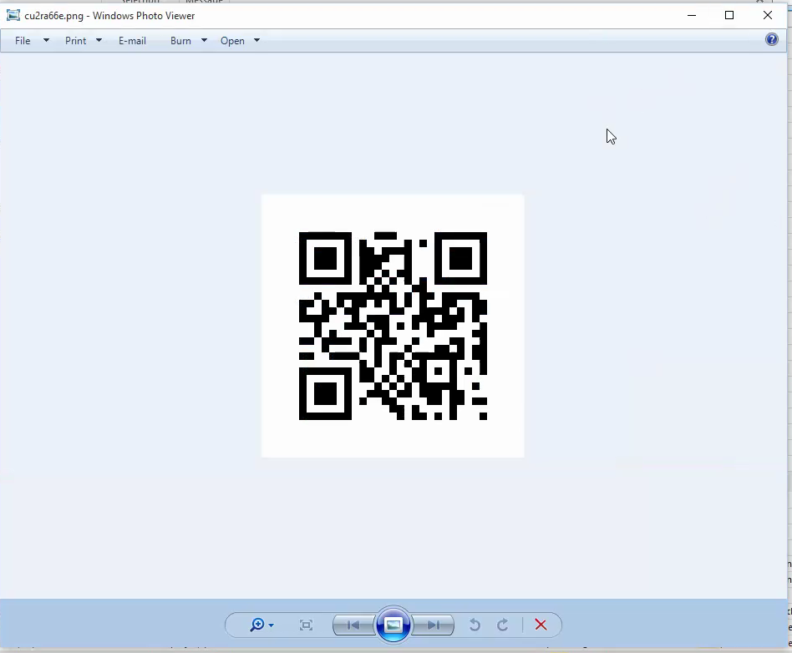

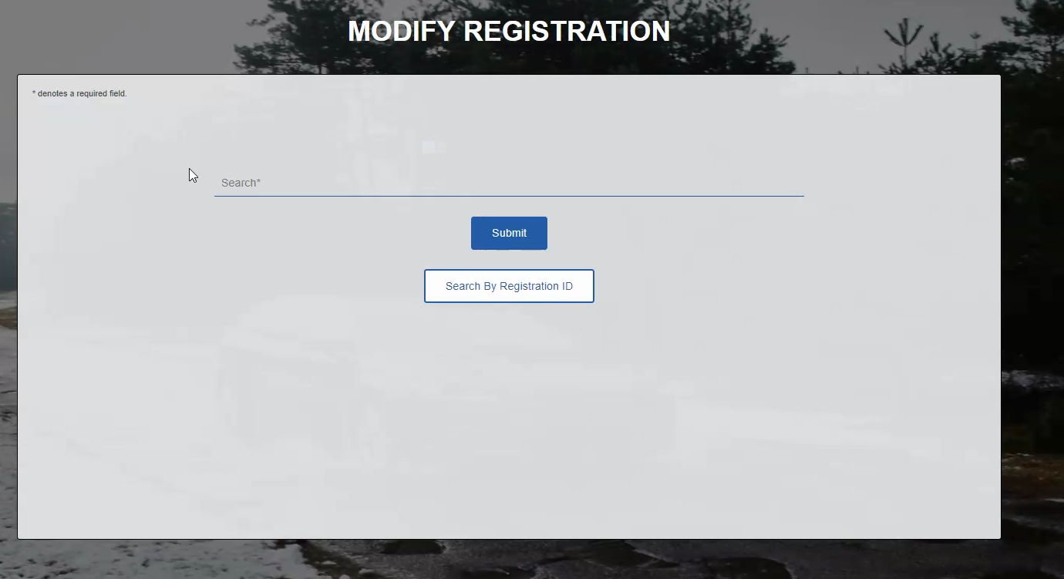

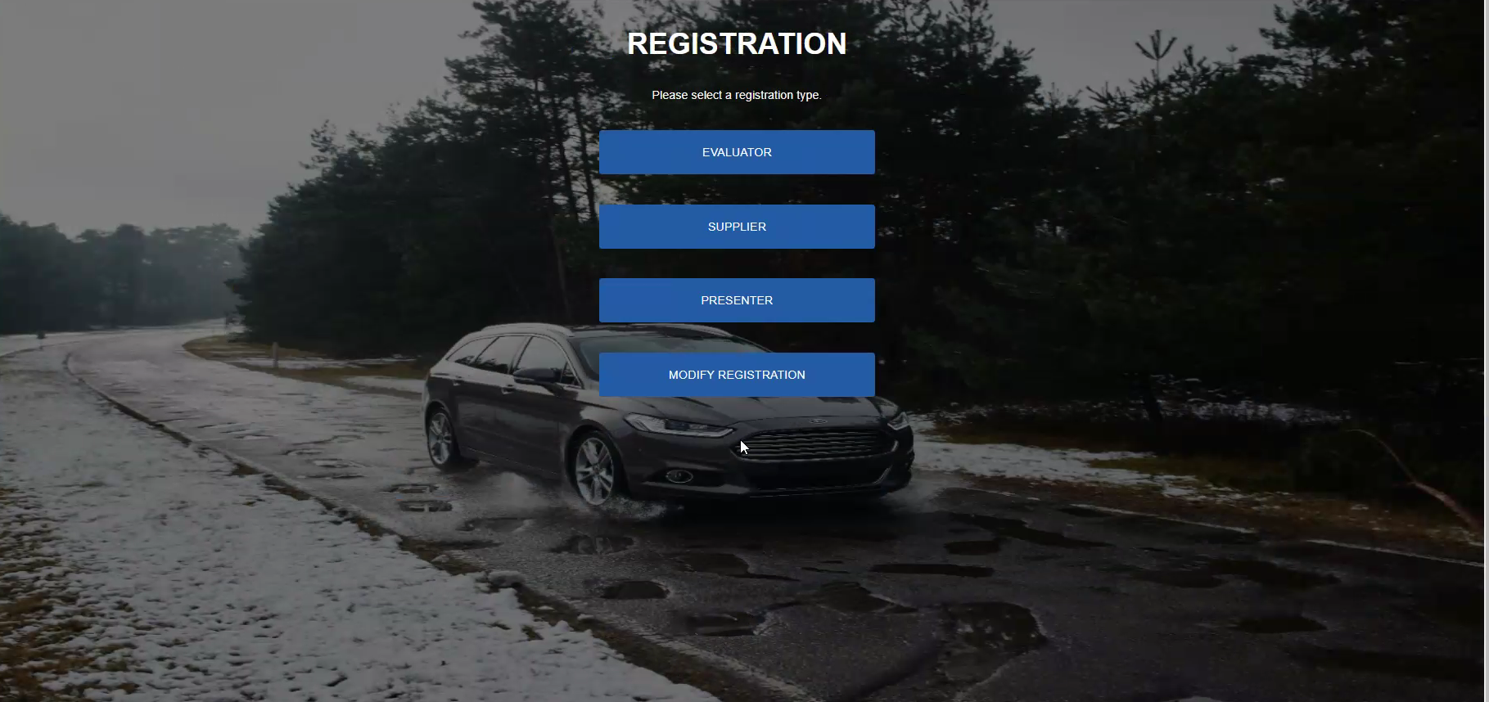

Issue about data combination for the supplier

Wonder if url can limit user to one record

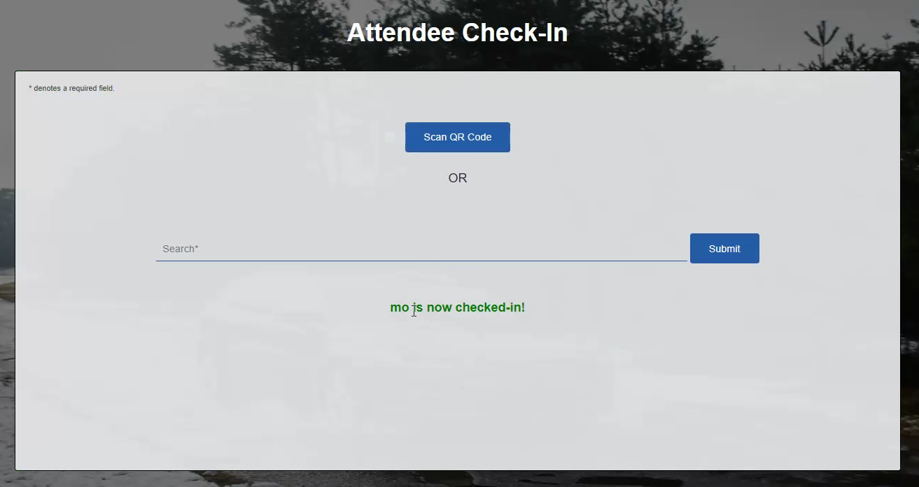

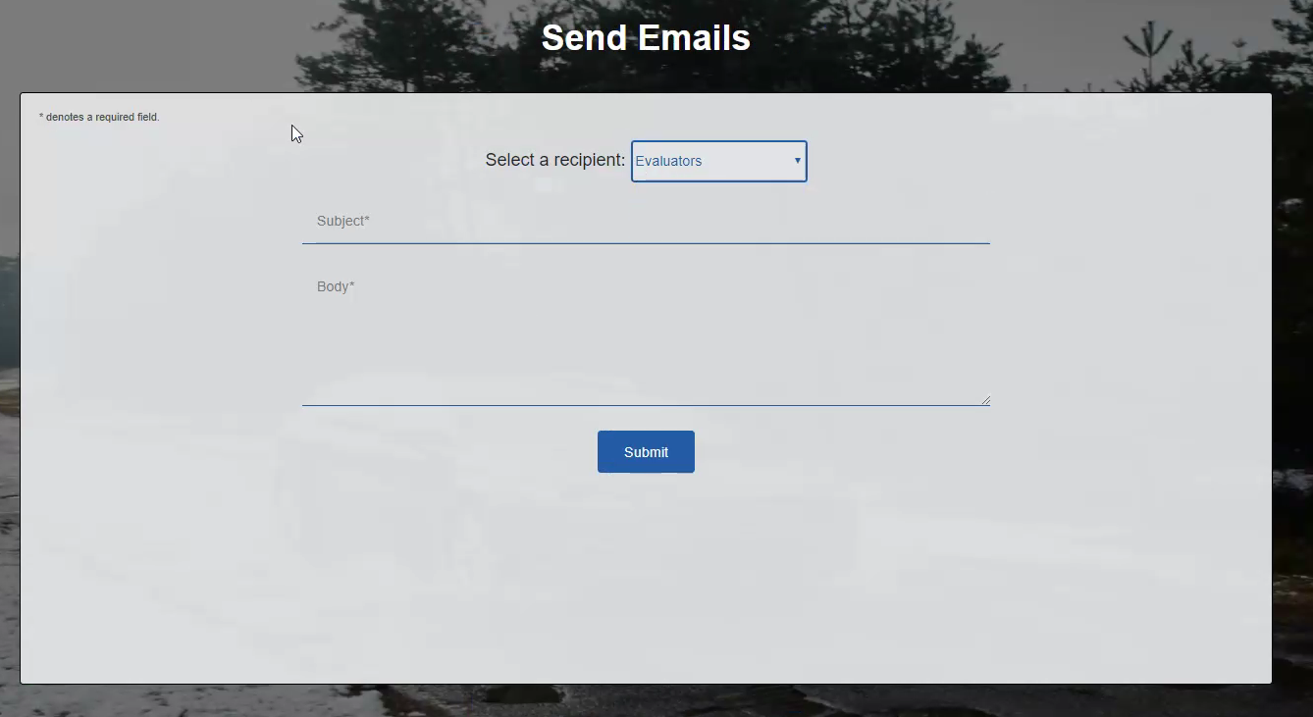

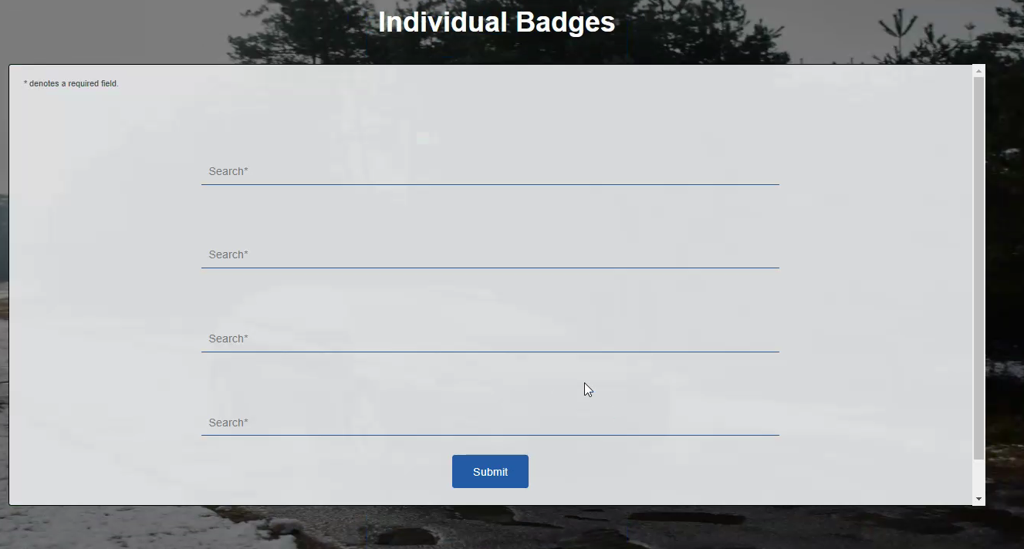

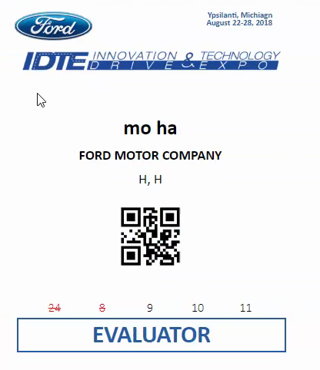

Current app is on local host

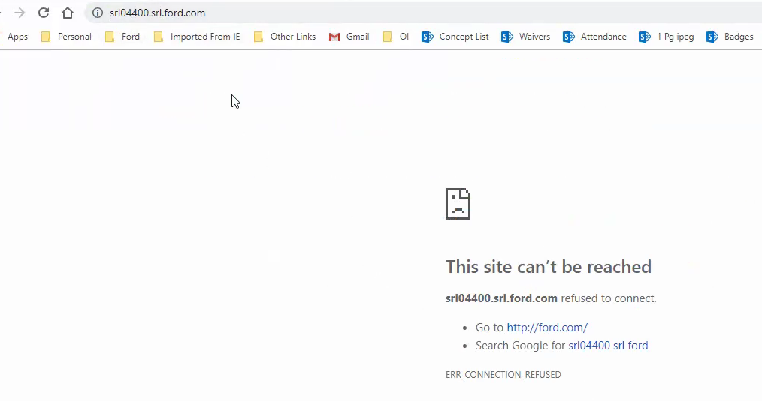

Still working on the automated email

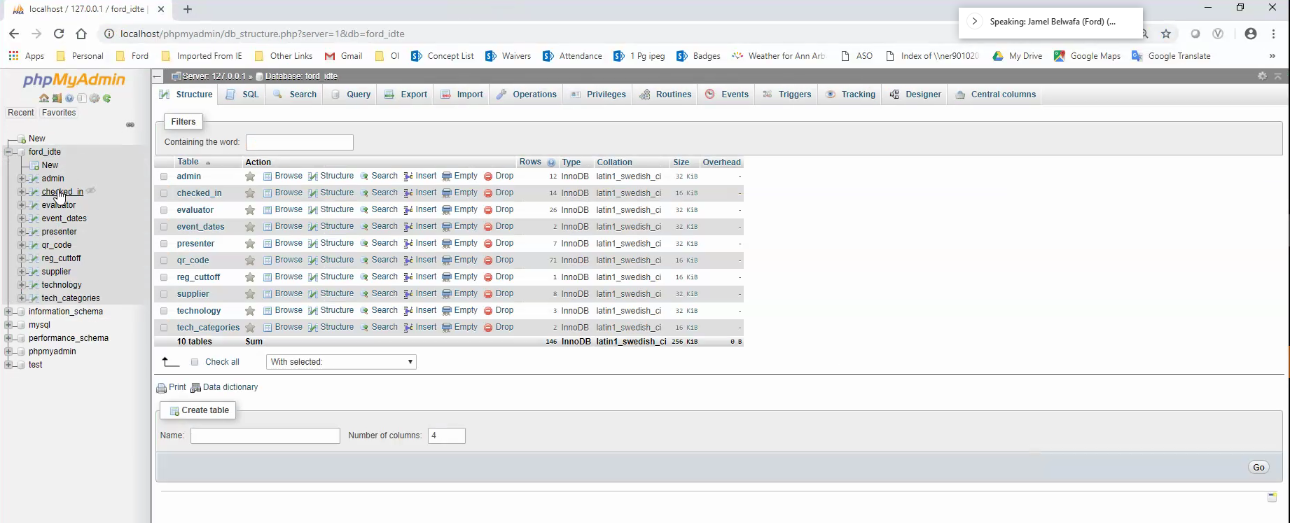

Above is the database used

## Test Plan

# Test

# Questions and Answers

## POC Questions

### Where is the POC site?

#### [https://it1.spt.ford.com/sites/PDAM/IDTE/SitePages/Home.aspx](https://it1.spt.ford.com/sites/PDAM/IDTE/SitePages/Home_old.aspx)

Do all pages need the correct language to display?

Yes

Will this set of pages be used for future Ford Innovation Drive and Technology Expo’s?

Who will develop the text for the disclosure statement?

Who will be developing the Roles and Responsibilities?

## Design Questions and Answers

Questions for the Architect

Is SharePoint capable of handling this security model?

Can Ford host a web site targeted for this set of pages?

Can Ford provide an Oracle or MS SQL database to support this data model?

Can it be assumed that Ford will provide the measures to support this security model?

Questions for the Business

What needs to happen if the Supplier email is not valid?

Answer to come after POC

Will there be any Key Performance Indicators?

Answer to come after POC

Web Page activity measure by hits

If a few Suppliers cannot access, what are the liabilities?

What will the support coverage be?

24 x 7

Will the support coverage include following up with Suppliers that were on the IDTE email distribution but have not accessed this page in the event they are having issues and cannot access the page?

Performance

What is the acceptable throughput?

What is the acceptable response time?

Information

What are the necessary inputs and outputs?

When must they happen?

Where is the required data to be stored?

How current must the information be?

What are the interfaces to external systems?

Economy

What are the areas of the system where costs must be reduced?

How much should costs be reduced or profits be increased?

What are the budgetary limits?

What is the timetable for development?

Control and Security

Efficiency

Service

Questions for the Developers

Who will help test this system?

Does Ford support the following technologies?

SharePoint Web Parts?

Yes

Will it support the security model?

C# and ASP pages?

Yes but the expertise is limited

InfoPath?

Yes, but Microsoft is discontinuing

Static Web Page with Java Applets and REST services

Yes and this is the best solution

### Each page

### Performance of each page

### Load testing

### Unit